**Project Initialization and Planning Phase**

| Date | 15 March 2024 |
| --- | --- |
| Team ID | 739942 |
| Project Name | Advanced COVID-19 Detection From Lung X-Rays With Deep Learning using IBM Watson. |
| Maximum Marks | 3 Marks |

**Define Problem Statements (Customer Problem Statement Template):**

Medical professionals face challenges in manually analyzing large numbers of chest X-ray images, which can lead to delays and diagnostic errors in detecting COVID-19 infections. There is a need for an automated, accurate, and efficient deep learning-based detection system, powered by IBM Watson, to assist doctors in delivering faster and more reliable COVID-19 diagnoses — ultimately improving patient care and outcomes

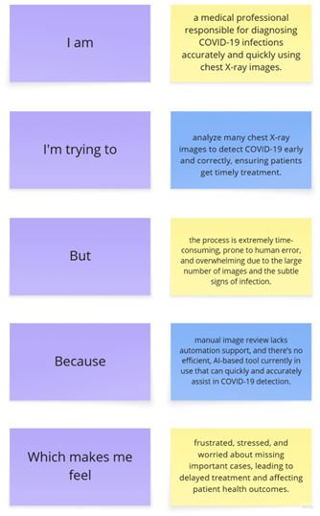

**Example:**

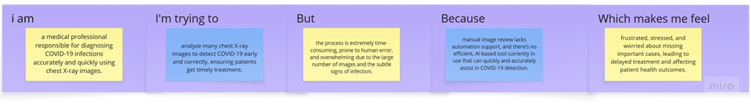

|  |  |  |  |  |  |
| --- | --- | --- | --- | --- | --- |
| **Problem**  **Statement (PS)** | **I am**  **(Customer)** | **I’m trying to** | **But** | **Because** | **Which makes me feel** |
| PS-1 | a doctor who checks chest X-ray images | detect COVID-19 infections early and accurately | it takes too long and mistakes can happen | there are too many images and no intelligent tool to assist | stressed and concerned about patient safety |
| PS-2 | a patient with COVID-19 symptoms | get a quick and correct diagnosis | the process is slow and not always reliable | doctors need a lot of time to manually examine each X-ray | anxious and worried about my health |